**Huda Husain Petkar**

**M. Sc DS & AI || L017 || ADBMS**

**Practical 1 - 06.12.24**

**Creation of Database**

create database mydb1;

use mydb1;

**Creation of table ‘Salesman’**

create table salesman( salesman_id int, name varchar(25), city varchar(25), commission float, primary key(salesman_id));

insert into salesman values(5001,'James Hoog', 'New York', 0.15),

(5002,'Nail Knite', 'Paris', 0.13),

(5005,'Pit Alex', 'London', 0.11),

(5006,'Mc Lyon', 'Paris', 0.14),

(5003,'Lauson Hen', NULL, 0.12),

(5007,'Paul Adan', 'Rome', 0.13);

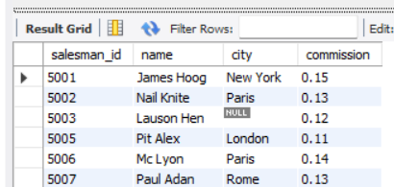

**Creation of table ‘Customer’**

create table customer(customer_id int, customer_name varchar(30), city varchar(25), grade int, salesman_id int,

Foreign key(salesman_id) references salesman(salesman_id), primary key(customer_id) );

insert into customer values

(3002,'Nick Rimando', 'New York', 100, 5001),

(3005,'Graham Zusi', 'California', 200, 5002),

(3001,'Brad Guran', 'London', NULL, NULL),

(3004,'Fabian Johns', 'Paris', 300, 5006),

(3007,'Brad Davis', 'New York', 200, 5001),

(3009,'Geoff Camero', 'Berlin', 100, NULL),

(3008,'Julian Green', 'London', 300, 5002),

(3003,'Jozy Altidor', 'Moscow', 200, 5007);

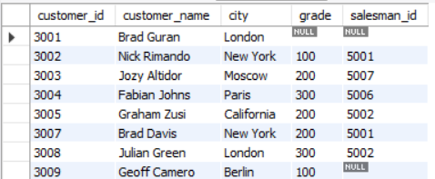

**Creation of table ‘Order’**

create table orrder(order_no int, purch_amt float, order_date date, customer_id int, salesman_id int, foreign key(customer_id) references customer(customer_id), foreign key(salesman_id) references salesman(salesman_id));

insert into orrder values

(70001, 150.5, '2016-10-05', 3005,5002),

(70009, 270.65, '2016-09-10', 3001,NULL),

(70002, 65.26, '2016-10-05', 3002,5001),

(70004, 110.5, '2016-08-17', 3009,NULL),

(70007, 948.5, '2016-09-10', 3005,5002),

(70005, 2400.6, '2016-07-27', 3007,5001),

(70008, 5760, '2016-09-10', 3002,5001),

(70010, 1983.43, '2016-10-10', 3004,5006),

(70003, 2480.4, '2016-10-10', 3009,NULL),

(70012, 250.45, '2016-06-27', 3008,5002),

(70011, 75.25, '2016-08-17', 3003,5007);

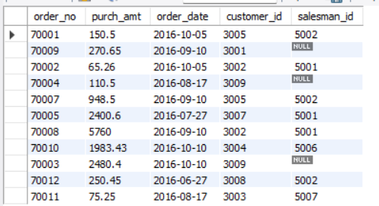

**1. Display name and commission for all the salesmen.**

select name, commission from salesman;



**2. Retrieve salesman id of all salesmen from orders table without any repeats.**

select distinct(salesman_id) from orrder;

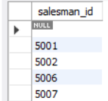

**3. Display names and city of salesman, who belongs to the city of Paris**

select name, city from salesman where city='Paris';

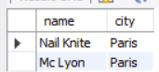

**4. Display all the information for those customers with a grade of 200**

select * from customer where grade = 200;

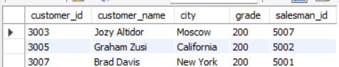

**5. Display the order number, order date and the purchase amount for order(s) which will be delivered by the salesman with ID 5001**

select order_no, order_date, purch_amt from orrder where salesman_id = 5001;

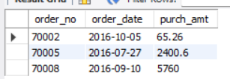

**12. Display all the customers, who either belong to the city New York or not had a grade above 100.**

select * from customer where city = 'New york' OR grade<100;

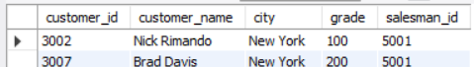

**13. Find those salesmen with all information who gets the commission within a range of 0.12 and 0.14.**

select * from salesman where commission between 0.12 and 0.14;

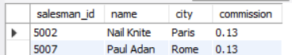

**14. Find all those customers with all information whose names are ending with the letter 'n'.**

select * from customer where customer_name LIKE '%n';

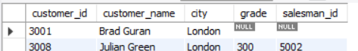

**15. Find those salesmen with all information whose name containing the 1st character is 'N' and the 4th character is 'l' and rests may be any character.**

select * from salesman where name LIKE 'N__l%';



**16. Find that customer with all information who does not get any grade except NULL.**

select * from customer where grade IS NULL;



**17. Find the total purchase amount of all orders.**

select sum(purch_amt) as total_purchase_amt from orrder;



To round up - select round(sum(purch_amt)) as total_purchase_amt from orrder;



**18. Find the number of salesman currently listing for all of their customers.**

select count(distinct(salesman_id)) from customer;



OR

select count(distinct(salesman_id)) AS no_of_salesman from customer;



**19. Find the highest grade for each of the cities of the customers.**

select city, max(grade) from customer group by city;

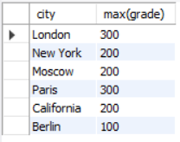

**20. Find the highest purchase amount ordered by each customer with their ID and highest purchase amount.**

select customer_id, max(purch_amt) from orrder group by customer_id;

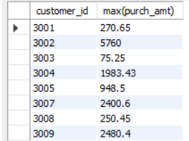

**21. Find the highest purchase amount ordered by each customer on a particular date with their ID, order date and highest purchase amount.**

select customer_id, max(purch_amt), order_date from orrder where order_date= '2016-08-17' group by customer_id ;

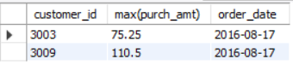

**22. Find the highest purchase amount on a date '2012-08-17' for each salesman with their ID.**

select salesman_id, max(purch_amt) from orrder where order_date = '2012-08-17' group by salesman_id;



**23. Find the highest purchase amount with their customer ID and order date, for only those customers who have the highest purchase amount in a day is more than 2000.**

select customer_id, max(purch_amt), order_date from orrder where purch_amt >2000 group by customer_id ;

**24. Write a SQL statement that counts all orders for a date August 17th, 2016.**

select count(order_no) as no_of_orders from orrder where order_date = '2016-08-17';

